5.7. Accounting for holidays
Streamline can account for calendar events like holidays and day offs.
To set the calendar:
1. Click on Item and choose Holidays option in the context menu
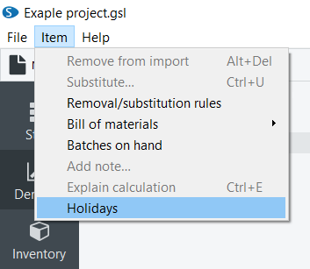
2. Choose the calendar of the needed country, or create a custom one with the holidays that affect the items sales.
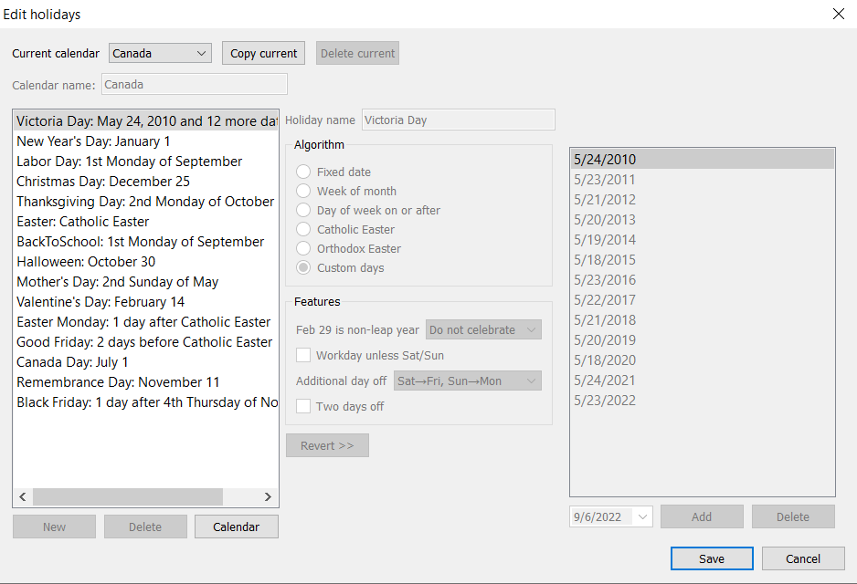
3. Once the needed calendars are set, choose the item or the category in the Tree view.
4. Choose the calendar using the Use holidays control in the Forecasting tab of the Panel panel.
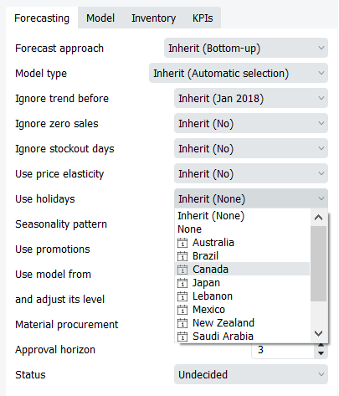
 | Use holidays feature doesn’t affect items with Seasonal&Trend model type, and can’t be used at the same time as Seasonality pattern feature.

Next: New Product Forecasting
Download PDF
Tracedump:
newBaseSize: 16pt
newBaseSizeInPt: 16

