7.3. Approval horizon feature
Streamline has an Approval horizon feature, which allows you to lock a given amount of time periods, so no changes to the demand plan can be made. The described locking mechanism is designed to freeze the state of the final demand forecast for a chosen amount of time while different company’s departments (sales, financial, marketing, etc.) are checking them or for the lead time period.
To set the Approval horizon feature:
1. Go to Demand Tab, and find the feature in the Forecasting tab (see figure below).
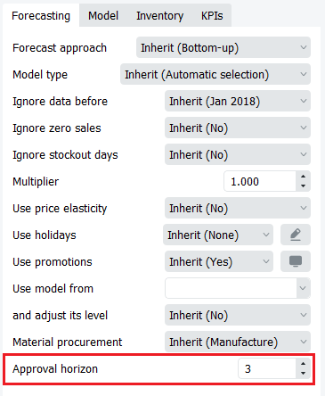
2. Choose the amount of time periods that need to be locked.
3. Press the Approve/Unapprove button in the Toolbar.
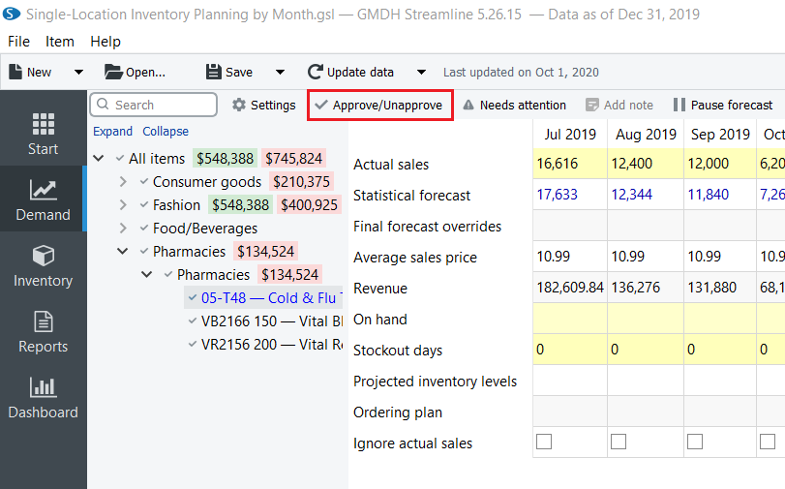
4. Notice how the chosen amount of future time periods are grayed out and not available for any additional overrides in the Table.
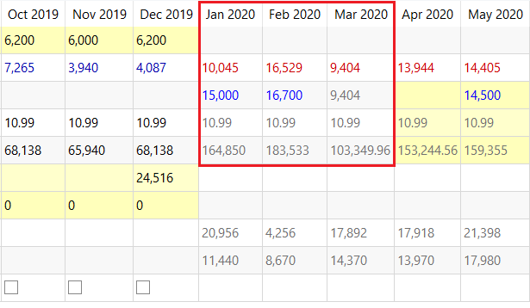
5. To unlock, press Approve/Unapprove button once again.

Next: Seasonality pattern
Download PDF
Tracedump:
newBaseSize: 16pt
newBaseSizeInPt: 16

