4.5.1. How to Import Data from Cin7
In this article we describe:
- correspondence between key terms in Cin7 and Streamline,
- integration limitations,
- imported data, and
- the data import workflow.

Key Terms
The key entities that Cin7 handles are products (Style codes), product options (Codes or SKUs), and branches. Streamline treats product options as items, product name as item description, and branches as locations.

Integration Limitations
Cin7 products can have size options that are only relevant to 'fashion products'. Let's call these as sized items and distinguish them from regular items. The table below shows the data that Streamline imports for regular and sized items.
Data | Regular item | Sized item
Sales history
On-hand history
The Cin7 API does not currently expose the on-hand history for sized items. Thus, Streamline is not able to:
- calculate inventory turn-over,
- compute the number of days in the period you had run out of inventory (Stockout days), and
- automatically determine whether lost sales are caused by a stock-out or zero demand
for sized items.

Imported data
Data imported into Streamline is described in the Inventory Management Systems article.

Data Import Workflow
Streamline uses Cin7 API to import the data. To authorize Streamline, Cin7 requires providing an API username and API key. The API username can be retrieved from Cin7 Integrations settings, whereas the API key is generated when creating a Cin7 API connection. Below we describe how to get these credentials.
The data import includes two steps:
- Retrieving the API username and API key.
- Importing the data into Streamline.

Retrieving API Username and API Key
To retrieve the API username:
1. Log in to your Cin7 account.
2. Go to the menu Admin > Settings Panel (see figure below).
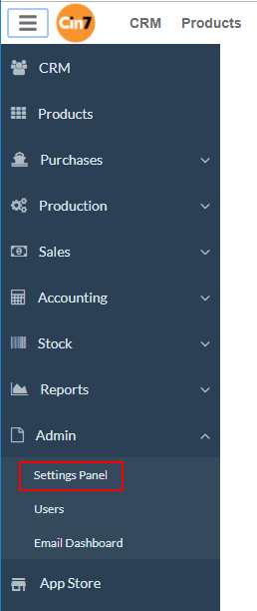
3. Expand the Integrations section and click the API v1 link (see figure below).
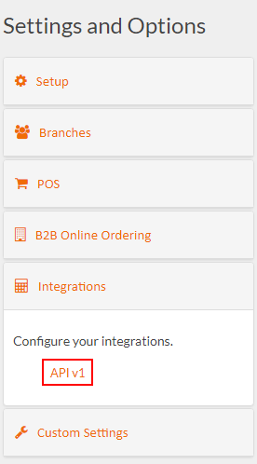
4. The API username is shown in the Auth section on the API Setup page (see figure below).
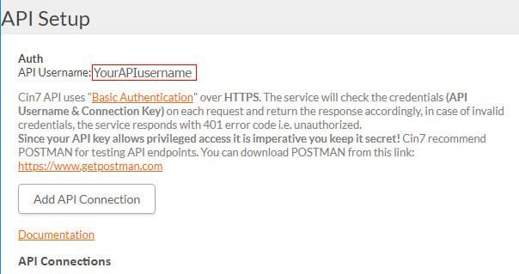
To get the API key, we need to create an API connection in Cin7. To do this:
1. Click the Add API Connection button (see figure below).
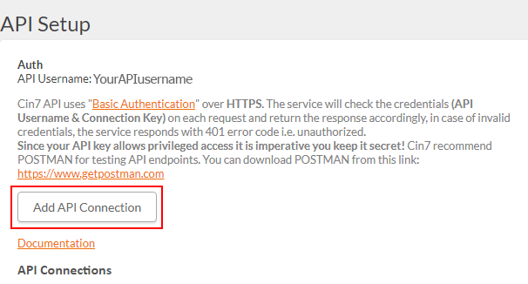
2. Enter a name for the connection and click the Save button (see figure below).
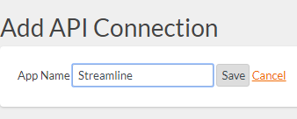
3. Now, the API key is generated (see figure below).
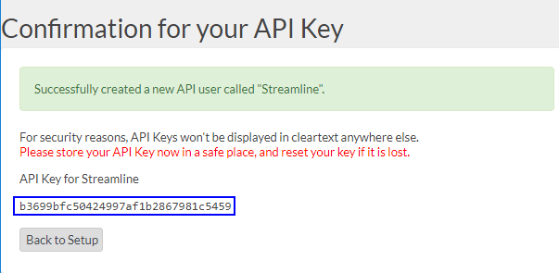
 | Store the generated key in a safe place. Cin7 displays it only once - now, on this page. If the key is lost, reset it.
The next step is to configure permissions for our API connection. This will ensure that Streamline has access only to the necessary data. To do this:
1. Go back to the API setup page by clicking the Back to Setup button.
2. Find your newly created connection in the API connections list and click the corresponding Permissions link (see figure below).
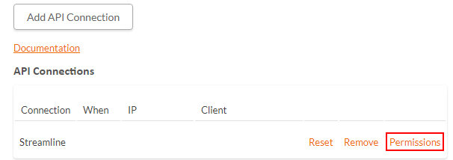
3. Set the permissions as shown in the figure below and click the Save button.
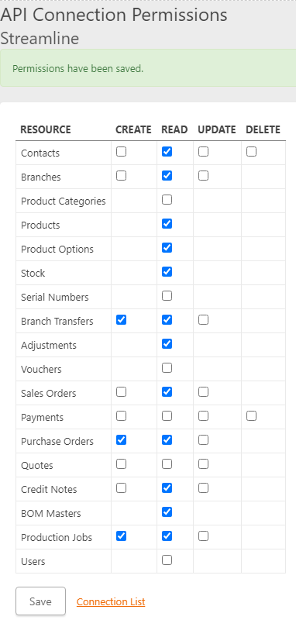

Importing the Data into Streamline
To create a new Streamline project based on Cin7 data:
1. Go to the menu File > New > Cin7 connection. The Cin7 connection dialog appears (see figure below).
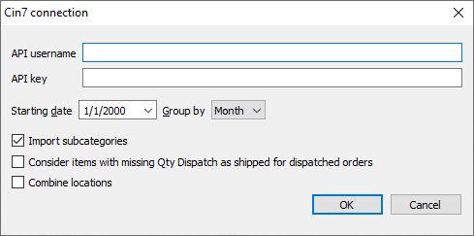
2. Enter your API username and API key.
3. Enter or choose the date to start the import from in the Starting date control.
To get accurate forecasts, we recommend providing Streamline with at least 24 months of sales history.
4. Choose the data aggregation period in the Group by control. Streamline automatically aggregates your data in the given periods (days, weeks, or months). For example, if you want to see the forecasts, replenishment plans, and other reports in months, group the data by month.
5. Click OK to start the import.
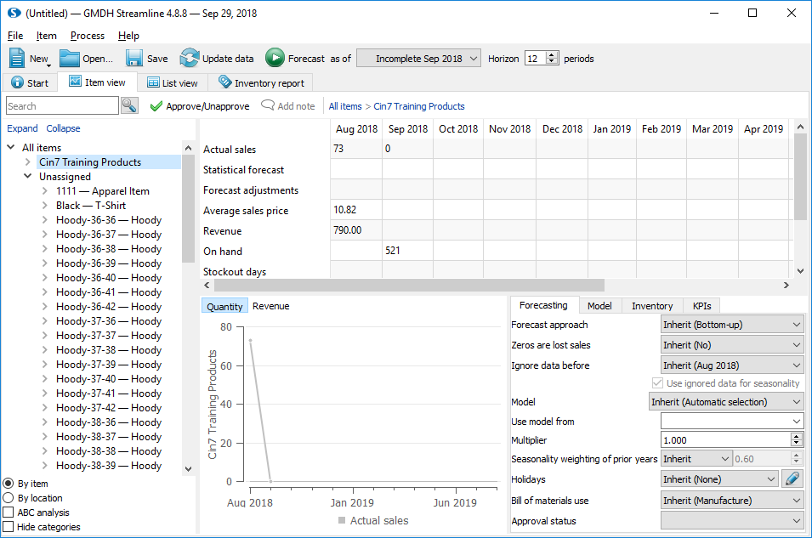

Import Options
- Import subcategories adds a new subcategory under the item category into the imported data hierarchy shown in the Tree View.
- Consider items with missing Qty Dispatch as shipped for dispatched orders. This option impacts the sales history imported from Cin7. If a sales order has fully dispatched date and there are lines that were not shipped at all (the Qty Dispatch is empty in Cin7), this option makes Streamline to add them into the sales history as if they were fully shipped to the customer.
- Combine locations option merges all your locations into one virtual warehouse. This is useful when your warehouses are located next to each other, so they can be planned as a single aggregated warehouse.

Next: DEAR
Download PDF
Tracedump:
newBaseSize: 16pt
newBaseSizeInPt: 16

