4.3. Data for Importing Categories
Consider several examples. The table below shows the raw data used to import channel categories into Streamline. Categories for items or locations can be imported similarly.
Date | Item | Location | Channel category | Channel sub-category | Channel | Qty sold
12/30/2023 | Item 1 | Location 1 | E-commerce | us.website1 | us_w1_customer1 | 100
11/10/2023 | Item 2 | Location 1 | E-commerce | us.website1 | us_w1_customer2 | 110
12/30/2023 | Item 1 | Location 1 | E-commerce | ca.website1 | ca_w1_customer1 | 100
11/10/2023 | Item 2 | Location 1 | E-commerce | ca.website1 | ca_w1_customer2 | 110
12/30/2023 | Item 1 | Location 1 | E-commerce | us.website2 | us_w2_customer1 | 130
11/10/2023 | Item 2 | Location 1 | E-commerce | us.website2 | us_w2_customer2 | 300
12/30/2023 | Item 1 | Location 1 | E-commerce | ca.website2 | ca_w2_customer1 | 130
11/10/2023 | Item 2 | Location 1 | E-commerce | ca.website2 | ca_w2_customer2 | 300
10/11/2023 | Item 1 | Location 1 | Physical distributor | US distributor | US main customers | 200
9/11/2023 | Item 2 | Location 1 | Physical distributor | US distributor | US other customers | 233
10/11/2023 | Item 1 | Location 1 | Physical distributor | Canada distributor | Canada main customers | 543
9/11/2023 | Item 2 | Location 1 | Physical distributor | Canada distributor | Canada other customers | 252
 | Each triple Item, Location, Channel must be unique. Otherwise, Streamline chooses a subset of unique records from the provided set randomly.
In Streamline this will create a hierarchy depicted in the figure below.
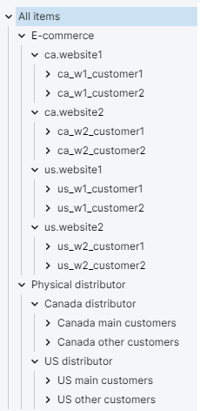
Empty categories at the end of the hierarchy are perfectly possible: Category1 > Category2 > ⌀ > ⌀ means that the item will be put into the Category2. The symbol ⌀ means an empty category.
Empty category within the hierarchy
Empty categories anywhere else in the hierarchy are also allowed but discouraged. For example, Category1 > ⌀ > Category3. In this case, Streamline creates a subcategory with an empty name.
Consider an example of Item Info table that illustrates the above statement. In this case, we use item categories (see table below).
Item | Location | Country | State | City | On hand
Item 1 | Shop 1 | US | New Jersey | Trenton | 100
Item 2 | Shop 2 | US | California | San Diego | 200
Item 1 | Boutique 1 | Monaco |  | Monaco | 300
The imported data hierarchy is depicted in the figure below.
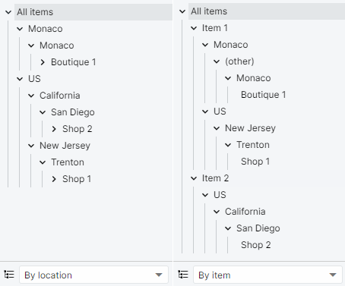
Empty category at the beginning of the hierarchy
Assume, we have a hierarchy of categories for items, however, there is an item that does not belong to any category. In this case, Streamline puts this item at the first category level. Below is an illustration using the Item Info table.
item | Item category 1 | Location | On-hand
Item 1 | Item category1 | Shop 1 | 100
Item 2 | Item category1 | Shop 2 | 200
Item 3 |  | Boutique 1 | 300
The result of the import is shown in the figure below.
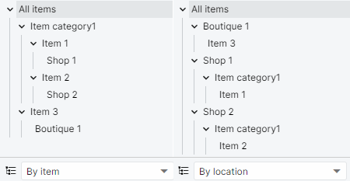
Tracedump:
newBaseSize: 16pt
newBaseSizeInPt: 16

