4.5.2. How to Import Data from DEAR
In this article we describe:
- integration limitations,
- imported data, and
- the data import workflow.

Integration Limitations
Currently, Streamline does not import the on-hand history of products from DEAR. This limitation makes Streamline unable to:
- calculate inventory turn-over,
- compute the number of days in the period you had run out of inventory (Stockout days), and
- automatically determine whether lost sales are caused by a stock-out or zero demand.

Imported data
Data imported into Streamline is described in the Inventory Management Systems article.

Data Import Workflow
Streamline uses DEAR API to import the data. To authorize Streamline, DEAR requires providing an Account ID and Application key. Below we describe how to get these credentials.

Generating Account ID and Appication Key
1. Go to the API integration page (see figure below).
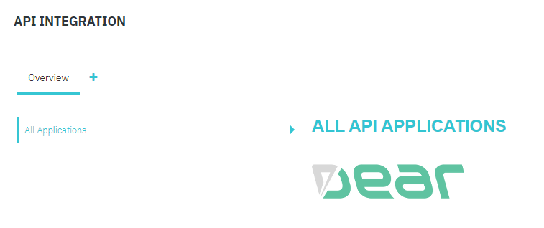
2. Click the Plus button and enter a name for the new application (see figure below).
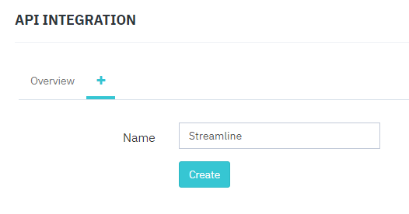
3. Click the Create button. After that, DEAR generates credentials for the new application (see figure below).
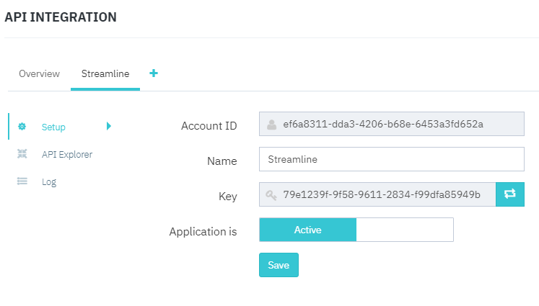

Creating a New Streamline Project
To create a new Streamline project based on DEAR data:
1. Go to the menu File > New > DEAR connection. The DEAR connection window appears (see figure below).
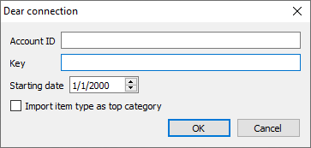
2. Fill in the Account ID and Key fields with the generated credentials.
3. Enter or choose the date to start the import from in the Starting date control.
 | To get accurate forecasts, we recommend providing Streamline with at least 24 months of sales history.
4. Click OK to start the import.

Import Options
- Import item type as a top category option adds a new level on top of your data hierarchy which you can see in the Tree View. This category level breaks imported items by the item type.

Next: Dynamics BC
Download PDF
Tracedump:
newBaseSize: 16pt
newBaseSizeInPt: 16

