Importing Data
To import data, please complete the following steps.
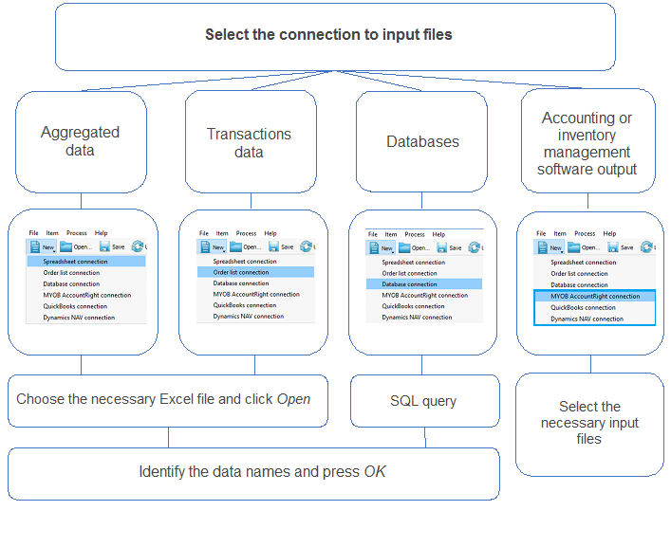
For effective analysis, Streamline allows to construct hierarchical data “tree”. If for sales forecasting/inventory planning the number of locations is important, then construct the data “tree” based on locations. Otherwise, construct a data “tree” based on item categories and item specifications.
The hierarchy of а future structure is created when data are imported into Streamline. Such hierarchy is based on top-down approach i.e. first select a product category, then subcategory etc.
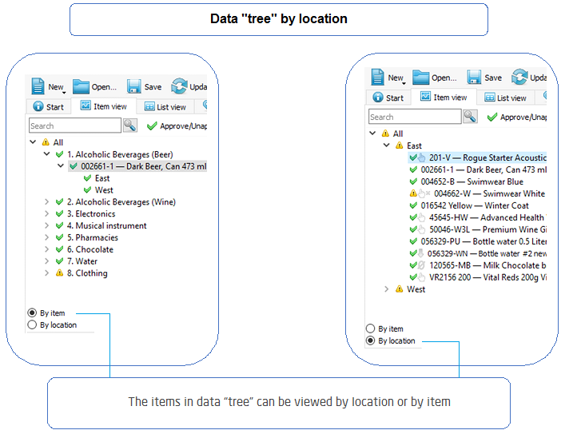
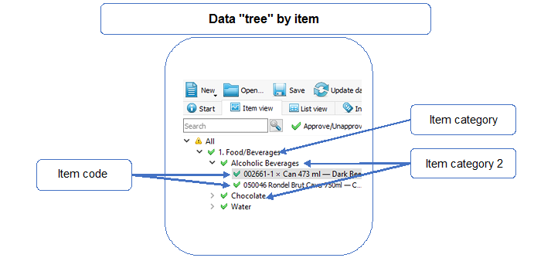
Tracedump:
newBaseSize: 16pt
newBaseSizeInPt: 16

