What data to import
Necessary input data depend on business goals and anticipated results. Such input data for generating forecasts are summarized as follows.
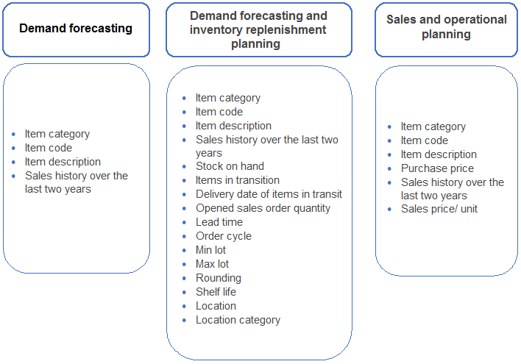
Tracedump:
newBaseSize: 16pt
newBaseSizeInPt: 16

