The All items report (or any other custom report) has a context menu that includes the most commonly used operations applied to the currently selected planning item in the table.
To open the context menu, right-click on the planning item (see figure below).
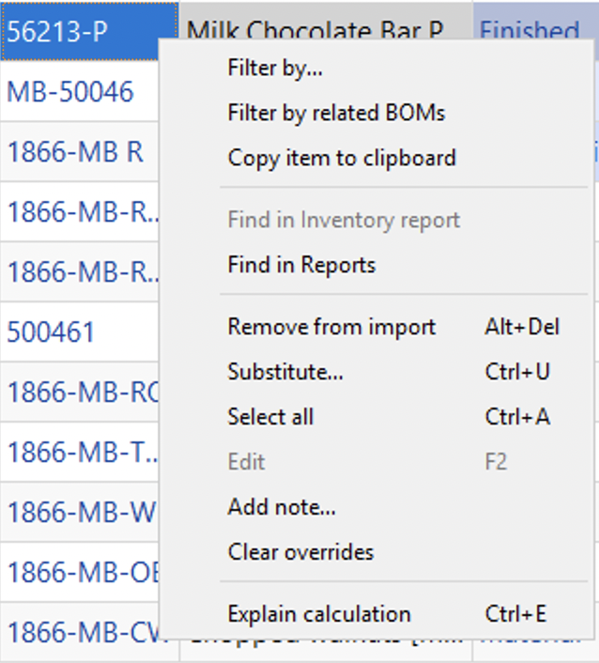
Below we give a description of the commands.
- Filter by… will open a new filter dialog with automatically applied criterias so you can quickly sort using these specifications.
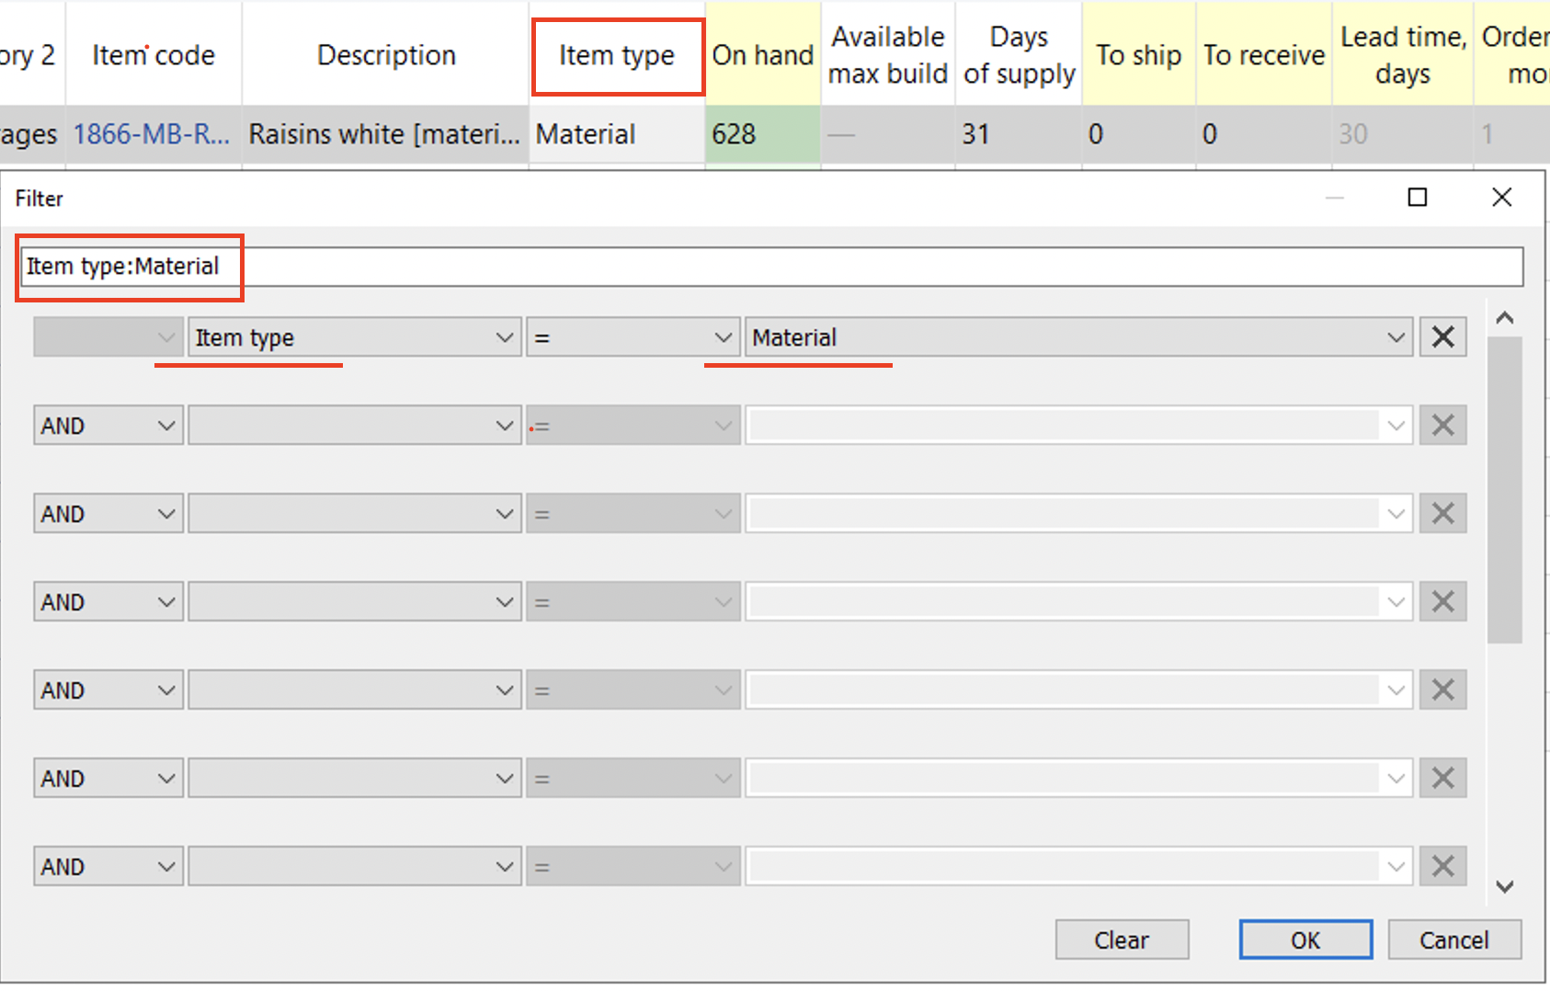
- Filter by related BOMs will open a new filter dialog where you can separate items related to the selected BOM.
- Copy item to clipboard copies the item code of the selected planning item to the clipboard.
- Find in Reports will take you to the selected item in Reports tab.
- Remove from import... bans the selected item code (not planning item) from import.
- Substitute merges the selected planning item with the planning item which code is provided in the appeared window on a channel basis (see figure below). If the provided item code exists in the project, this operation removes the item code of the selected planning item from the project, otherwise, it renames it.
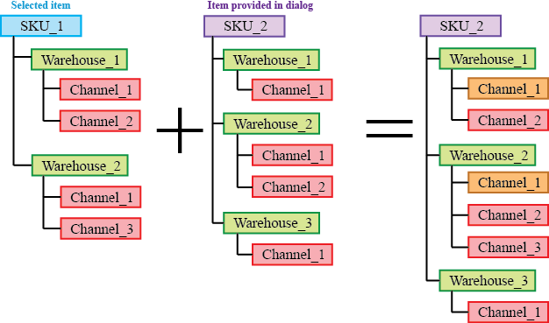
Orange in the figure above indicates the channels with merged histories.
- Select all selects all items in the report.
- Edit switches the selected cell into editing mode allowing you to enter a new value for the parameter. This command is only active for the cells in editable columns (the headers shown in yellow). It can be used for a mass changing of a certain replenishment parameter for a given set of planning items.
- Add note opens the Edit note dialog (see figure below) where you can add, remove, or edit the note for the selected planning item.
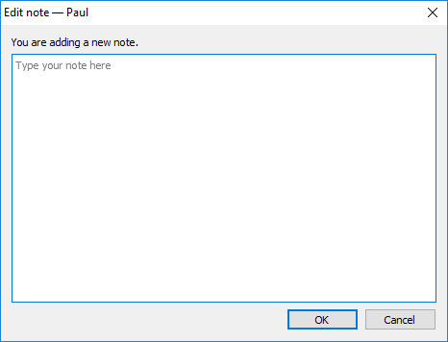
- Clear overrides will revert back all the changes that have been made to the selected item.
- Explain calculations shows the Explain inventory calculation dialog for the selected item.
Tracedump:
newBaseSize: 16pt
newBaseSizeInPt: 16

