5.5. Manual Adjustments
GMDH Streamline enables you to:
- 4.5.1. Adjust statistical forecasts. Statistical forecasts adjustments allow you to override forecasts generated by Streamline, for example, when you need to account for promotions, clearance sales or other events which are not represented in the historical data, and so can’t be seen by the application.
- 4.5.2. Fine-tune the forecasting models. Streamline allows fine-tuning the models which it generates. It includes changing the forecasting model type, model coefficients, and increasing/decreasing the model output.
- 4.5.3. Perform what-if revenue analysis. The analysis provides what-if simulation based on expected sales prices changes.
- 4.5.4. Make historical data corrections. A unique feature of Streamline is making manual corrections to imported historical data. If your sales or On hand history has irregular data, you can amend them right in the program.
Any cell with a yellow background can be edited manually across the whole application.
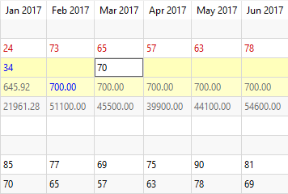
It’s easy to revert to the original value in the edited cell, just clear the cell and press Enter. Any manual adjustments are displayed in blue.

Next: Forecasts Adjustments
Download PDF
Tracedump:
newBaseSize: 16pt
newBaseSizeInPt: 16

