4.1. Streamline Connectors
Data import is the first step in creating a new project in Streamline. Streamline can import data from numerous data sources starting from Excel files in different formats and ending with various databases and built-in connectors for popular ERP systems (see figure below).
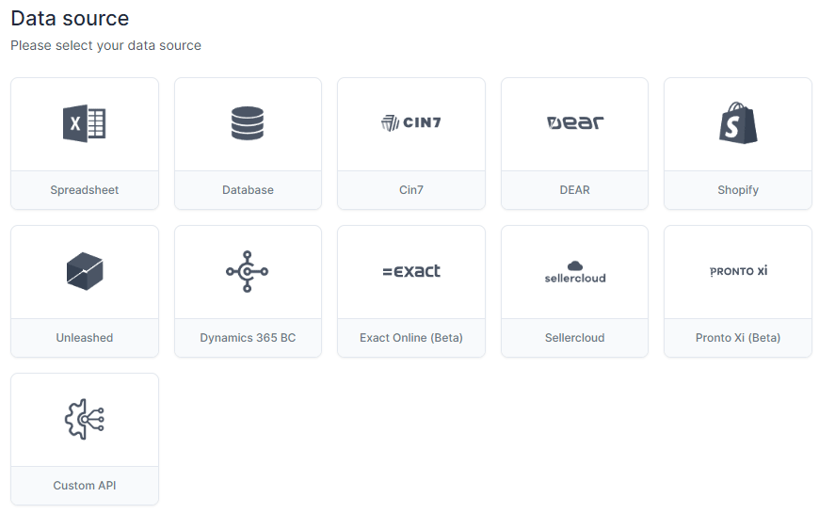
All Streamline's connections can be divided into the following categories:
- Excel connection. This is designed to import data from Excel files and CSV files in certain formats.
- Database connection. This connection is the most generic and powerful. It allows you to pull data from any database that has an ODBC driver.
- 3rd party system connections. These connections were specifically designed to work with a certain accounting or inventory management system. They have a simple user interface and require minimum effort to import the data into Streamline.
- Custom API connection. This one should be used if your ERP system doesn't have a built-in API that provides required data. In this case, you should implement custom-made API endpoints on the ERP's side according to the technical requirements.
Each of these connections imports a different set of data that is limited by certain data source abilities. For example, the ODBC/OLEDB connection allows importing/exporting the full range of data, unlike the Excel connection based on Aggregated data has the minimum abilities.

Next: Imported data
Download PDF
Tracedump:
newBaseSize: 16pt
newBaseSizeInPt: 16

