4.5.16. How to Import Data from Unleashed
To import data from Unleashed, open the Unleashed connection dialog by clicking menu File > New > Unleashed connection.
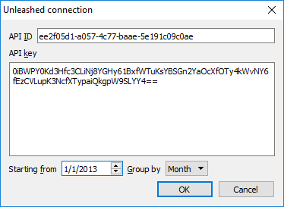
To retrieve data from Unleashed, the connector requires entering the API Id and API Key of your Unleashed company. To get this information, please go to the following page: https://go.unleashedsoftware.com/v2/Integration/Api.
Set the beginning point of the data from which you want to import using the Starting from option.
 | To get accurate forecasts, we recommend providing Streamline with at least 24 months of sales history.
The Importer can automatically aggregate your data in periods (days, weeks, months) using the Group by option. So for example, if you would like to see the forecasts, procurement plan, and other reports in months, group the data by month.
After filling in the necessary information, click OK.
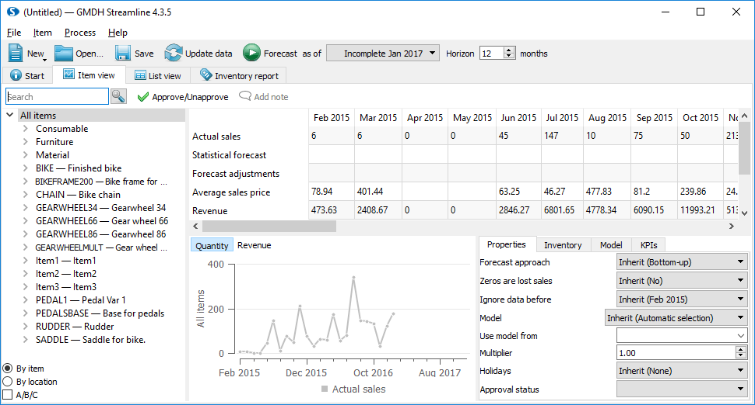

Next: Multiple Connection
Download PDF
Tracedump:
newBaseSize: 16pt
newBaseSizeInPt: 16

