- By item. All the information (forecasts, historical data, inventory) is, first, aggregated by location and location categories, and then, by item and item categories. The tree shows items on top of locations (see figure below).
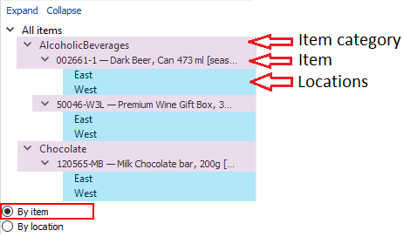
- By location. The information is, first, aggregated by item and item categories, and then, by location and location categories. So, the tree shows locations on top of items (see figure below).
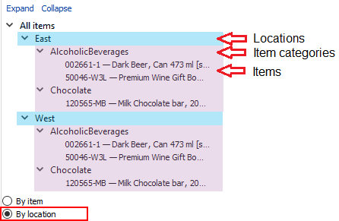
- By channel. The information is, first, aggregated by item and item categories, and then, by channel. The tree shows channels on top of items (see figure below).
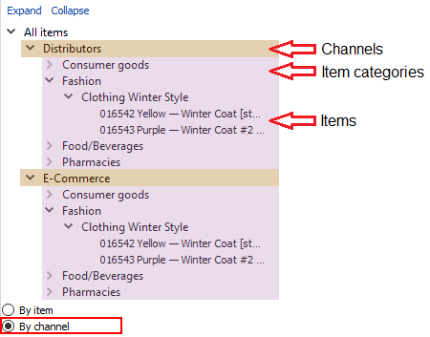
Tracedump:
newBaseSize: 16pt
newBaseSizeInPt: 16

